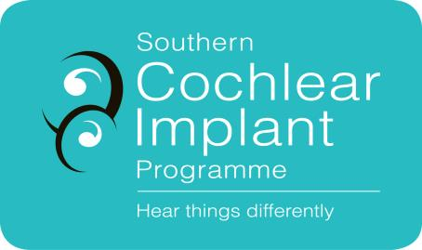
Southern Cochlear Implant Programme
Paediatric Referral Form (0 – 19 years)

☐ The child’s parent/caregiver has given verbal consent for this referral and for SCIP to access medical and education information relevant to cochlear implant assessment (Ensure box is ticked before proceeding)

Please complete referrer details:
Date of referral:
Referrer’s Name & Title:
Clinic Address:
Clinic Phone:
Contact email:

Referral Criteria | Information Required
NZ Permanent Residency  Patients will not be able to access services in the publicly funded service if they do not hold NZ Permanent Residency. | Copy of patient’s birth certificate, citizenship certificate, or Permanent Residency visa.
Baseline Audiometric Criteria  - Children with a bilateral severe hearing loss or worse, from 1 kHz to 8 kHz on ABR testing or on an unaided test.  - Children with limited aided speech information above 2 kHz (as seen on speech-mapping). Children with a severe reverse sloping hearing loss or worse whose speech and language is not progressing adequately.  - Children with auditory neuropathy spectrum disorder who are not progressing in their speech and language development.  - Children who have recently suffered from meningitis which has caused a sensorineural hearing loss should be referred urgently upon diagnosis. A CT/MRI to be arranged through the local ENT service.  - Children referred who are older than three years of age should have documented evidence of oral language developing.  - Children who are over four years of age with no oral language will be considered and discussed only on a case-by-case basis.  - A child older than five years of age with no language is unlikely to benefit from a cochlear implant.  - Children with additional needs will be accepted for assessment | Please attach all of the following audiological information:  - ABR result summary if available  - Diagnostic audiogram (speech audiometry, immittance audiometry, OAEs, aided testing)  - Previous audiograms & speech audiometry  - Copies of any ENT and Paediatrician reports and letters.
Hearing Aids  The patient should be optimally aided. | Please enclose:  - Real ear measures

Please complete all patient details:
Client Name:
Client Address:
Date of Birth:
Name and address of General Practitioner:
Name of Advisor on Deaf Children (if applicable):
Age hearing loss confirmed:
Date hearing aids first fitted:
Make and Model of current Hearing Aids and Date Fitted:
Earmould Type and Date Fitted:
Cause of hearing loss: e.g. meningitis, Connexin mutation, EVAS, CMV, other.
Additional diagnoses: e.g. syndromes, global developmental delay, vision
Brief description of hearing history and functional hearing: Click here to enter text.

Please ensure copies of the following are enclosed:
Please email documents to reception@scip.co.nz or post to
Clinical Co-ordinator
Southern Cochlear Implant Programme
Milford Chambers
St George’s Hospital
249 Papanui Rd
Christchurch 8014

☐ Proof of New Zealand Permanent Residency
☐ All available audiograms

☐ Copy of most recent real ear measures

☐ ENT and Paediatrican reports and letters (if available)

