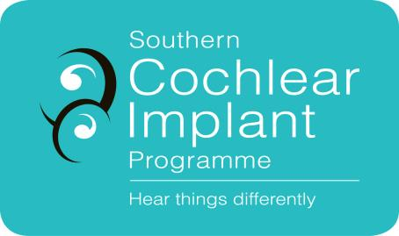
Paediatric Referral Form (0 – 19 years)

☐ The child’s parent/caregiver has given verbal consent for this referral and for SCIP to access medical and education information relevant to cochlear implant assessment (Ensure box is ticked before proceeding)

Please complete referrer details
Date of referral
Referrer’s Name & Title
Clinic Address
Clinic Phone
Contact email

Referral Criteria | Information Required
NZ Permanent Residency  Patients will not be able to access services in the publicly funded service if they do not hold NZ Permanent Residency. | Copy of patient’s birth certificate, citizenship certificate, or Permanent Residency visa.
Baseline Audiometric Criteria  - Children with a bilateral severe hearing loss or worse, from 1 kHz to 8 kHz on ABR testing or on an unaided test.  - Children with limited aided speech information above 2 kHz (as seen on speech-mapping). Children with a severe reverse sloping hearing loss or worse whose speech and language is not progressing adequately.  - Children with auditory neuropathy spectrum disorder who are not progressing in their speech and language development.  - Children who have recently suffered from meningitis which has caused a sensorineural hearing loss should be referred urgently upon diagnosis. A CT/MRI to be arranged through the local ENT service.  - Children referred who are older than three years of age should have documented evidence of oral language developing.  - Children who are over four years of age with no oral language will be considered and discussed only on a case-by-case basis.  - A child older than five years of age with no language is unlikely to benefit from a cochlear implant.  - Children with additional needs will be accepted for assessment | Please attach all of the following audiological information:  - ABR result summary if available  - Diagnostic audiogram (speech audiometry, immittance audiometry, OAEs, aided testing)  - Previous audiograms & speech audiometry  - Copies of any ENT and Paediatrician reports and letters.
Hearing Aids  The patient should be optimally aided. | Please enclose:  - Real ear measures

Please complete all patient details
Client Name
Client Address
Date of Birth
Parent/caregiver name and contact details
Email:
Phone:
Name and address of General Practitioner
Name of Advisor on Deaf Children (if applicable)
Age hearing loss confirmed
Date hearing aids first fitted
Make and Model of current Hearing Aids and Date Fitted
Earmould Type and Date Fitted
Cause of hearing loss: eg. meningitis, Connexin mutation, EVAS, CMV, other
Additional diagnoses: eg. syndromes, global developmental delay, vision
Brief description of hearing history and functional hearing: Click here to enter text.

Please ensure copies of the following are enclosed:
Please email documents to reception@scip.co.nz or post to
Clinical Co-ordinator
Southern Cochlear Implant Programme
Milford Chambers, St George’s Hospital
249 Papanui Rd, Christchurch 8014

☐ Proof of New Zealand Permanent Residency
☐ All available audiograms
☐ Copy of most recent real ear measures
☐ ENT and Paediatrican reports and letters (if available)

Privacy Statement
SCIP will manage your health information in accordance with our Privacy Statement, which explains what information we collect, why we need it, how we will use it and who we might need to share it with. If you have any concerns about providing us with information, or authorising us to collect information from third parties, talk to us about it and we can help you understand why we need it. Please refer to our website for our full Privacy Statement. www.scip.co.nz

